**PIPSTA003 – model A+ assembly instructions**

Contents

Revision History 2

Difficulty Level: 2

Time to Complete: 2

Who Should Read This Document 2

Kit Contents 3

You Will Need… 4

Build Procedure 4

Next Steps 11

# Revision History

|  |  |  |  |  |  |
| --- | --- | --- | --- | --- | --- |
| Revision | Author | Date | | Description | |
| 1.0 | SE/AH | 09/12/14 | | First Release | |
| Difficulty Level: | | | * You will need an antistatic wrist strap connected to earth and a small cross-head screw driver | |
| Time to Complete: | | | * Allow 30-45 minutes to build your Pipsta | |

# Who Should Read This Document

Owners of Raspberry Pi Model A+ can use this procedure to guide them from unpacking their Pipsta kit to the completion of the mechanical build.

Children may need adult supervision and occasional assistance during this process.

# Kit Contents

|  |  |  |
| --- | --- | --- |
| 1x Pipsta  USB and NFC  Thermal Mini-Printer    1x USB ‘A’ to Mini ‘B’ Cable | 1x Universal Mains Power Supply Adaptor    4x Regional Click-In Plug Faces | 1x PSA Cable    2x Side Plastics |
| 1x Back Plastics    1x Base Plastics | 1x Front Plastics    1x Grounding Wire | 1x Top Plastics    4x M2.5 Nuts |
| 4x M2.5x6 Machine Screws    1x Pipsta Label | 5x M2.5x8 M-F Hex Stand-offs    4x Self-Adhesive Rubber Feet | 1x Paper Roll  1x Linerless Label Roll |

# You Will Need…

* An antistatic wrist strap connected to earth
* A small cross-head screw driver

# Build Procedure

1. Take the protective film off the plastic parts, laying them flat on a clean surface so as not to cause abrasions/scratches. Ensure the discarded protective film is kept away from both the Mini-Printer and your Pi.

|  |  |  |
| --- | --- | --- |
|  | **TIP**: | The removal of the protective film from the plastics can produce an electrostatic charge that can damage the electronics on your Raspberry Pi and Pipsta Printer. |

1. Put on your ESD wrist strap, and ensure the lead has a good earth connection.
2. Feed 4x M2.5x8 M-F hex stand-offs through the base plastics as shown below, heeding the orientation shown in *Figure 1* below.
3. Fit 4x M2.5 nuts to the other side of the base plastics. Manually tighten the nuts and stand-offs

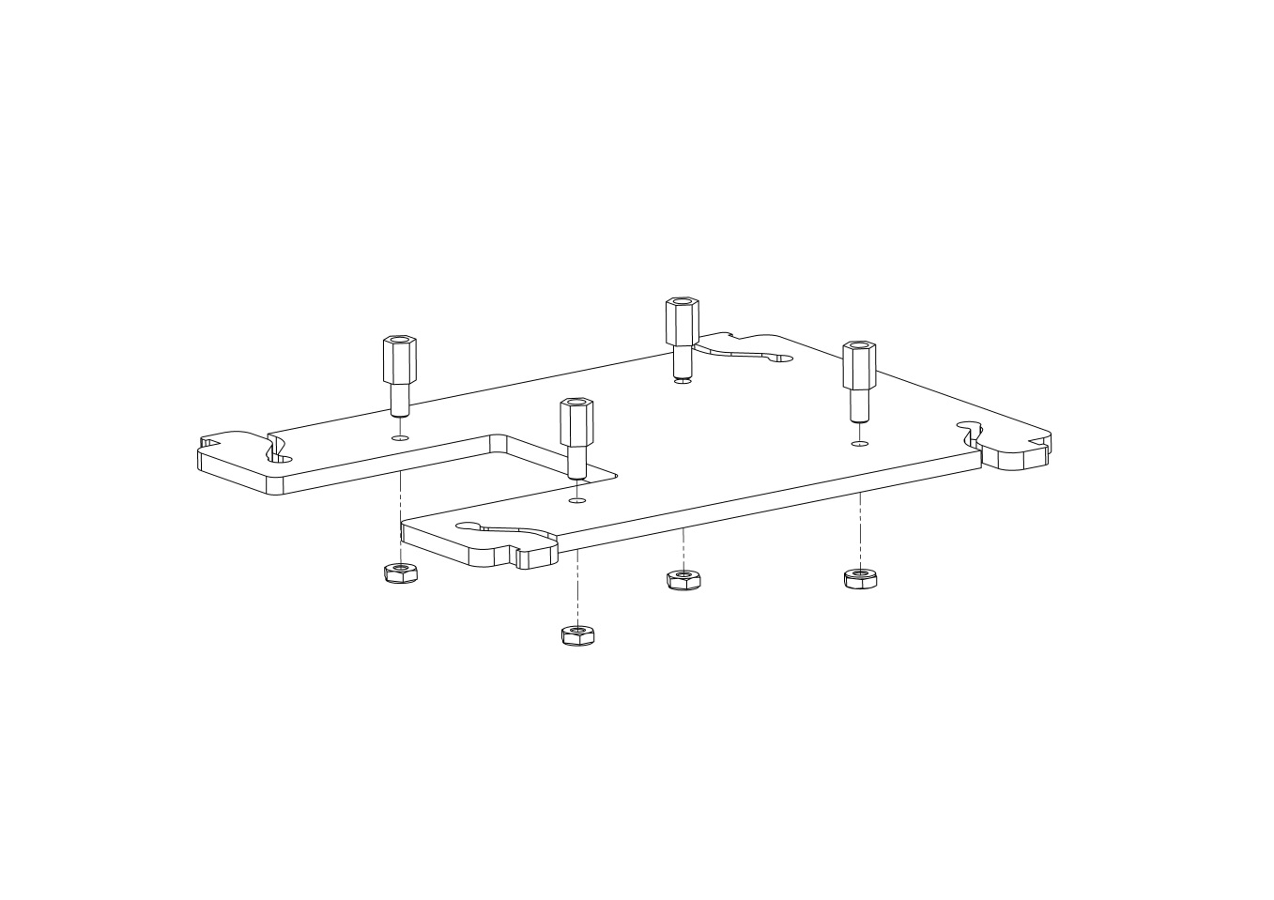

*Figure 1*

1. Fit 4x self-adhesive rubber feet to the underside (the side with nuts) of the base plastics as shown in *Figure 2*. Note that the position of the feet will affect the stability of the unit in use.

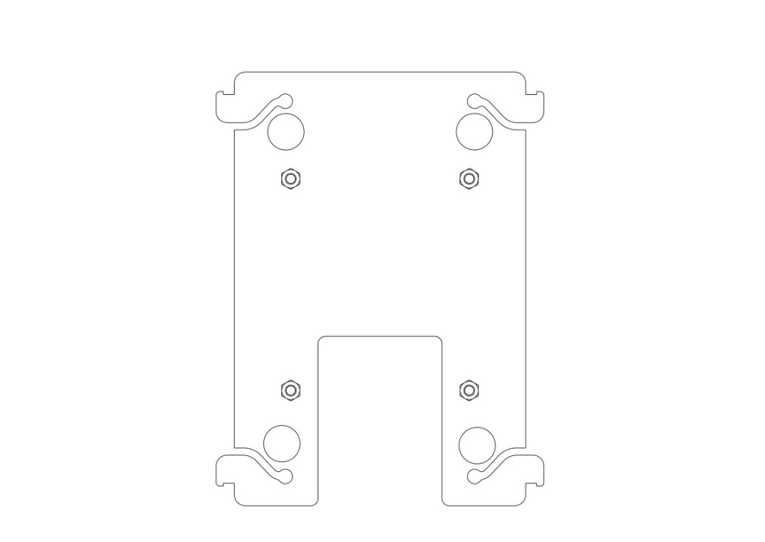

*Figure 2*

7) Fix the Raspberry Pi to the assembly onto the base with 3x M2.5x6 screws, as shown in *Figure 3*, ensuring that the Raspberry Pi is orientated correctly (Micro SD card connector to the gap in the base.)

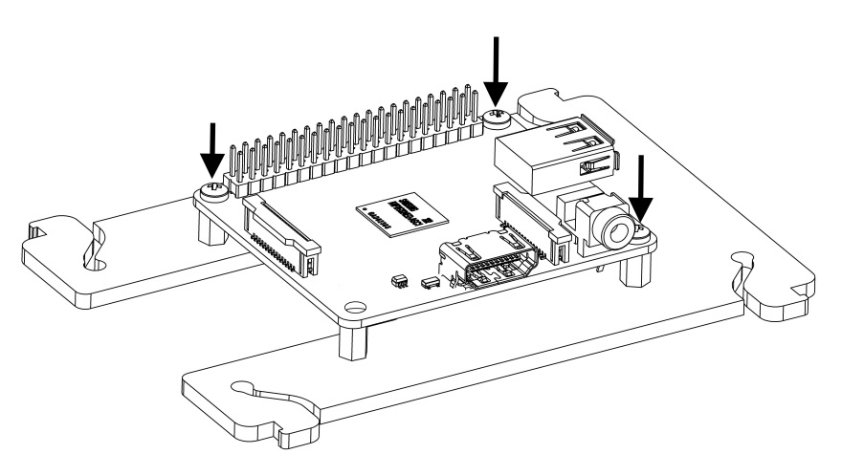

*Figure 3*

1. Fit 1x M2.5x8 M-F hex stand-off at the remaining fixing location at the front of the Raspberry Pi (near to the Raspberry Pi Micro USB power connector.)
2. Fit the side plastics to the left-hand side of the base plastics as shown in *Figure 4*. Note that both left and right side plastics are identical.

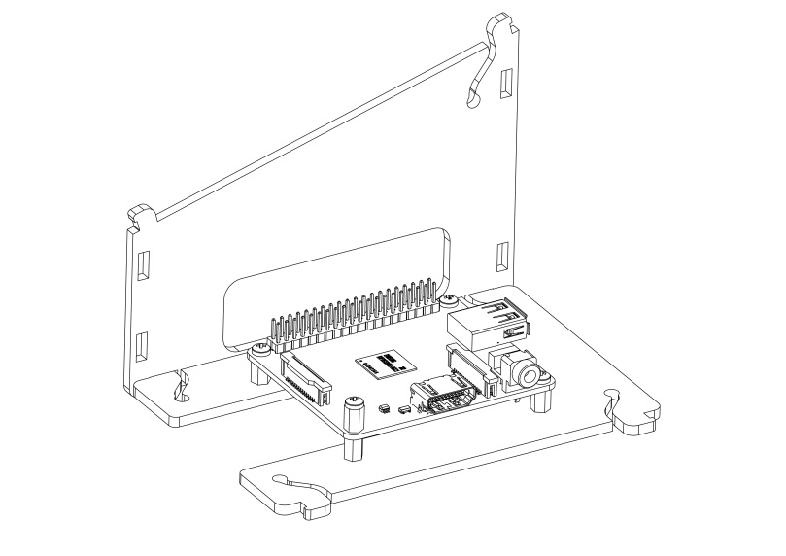

*Figure 4*

1. Set the assembly aside, and fit the mini-printer into the top plastics as shown in Figure 5, ensuring the earth strap is fed through the aperture. NOTE the position of the notch at the **front** of the top plastics

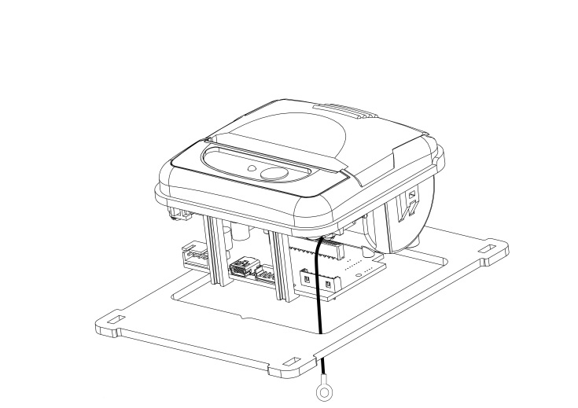

*Figure 5*

1. Using 1x M2.5x6 screw, attach both the printer earth strap eyelet and the grounding wire to the hex stand-off at the front right of the unit as shown in *Figure 6*.

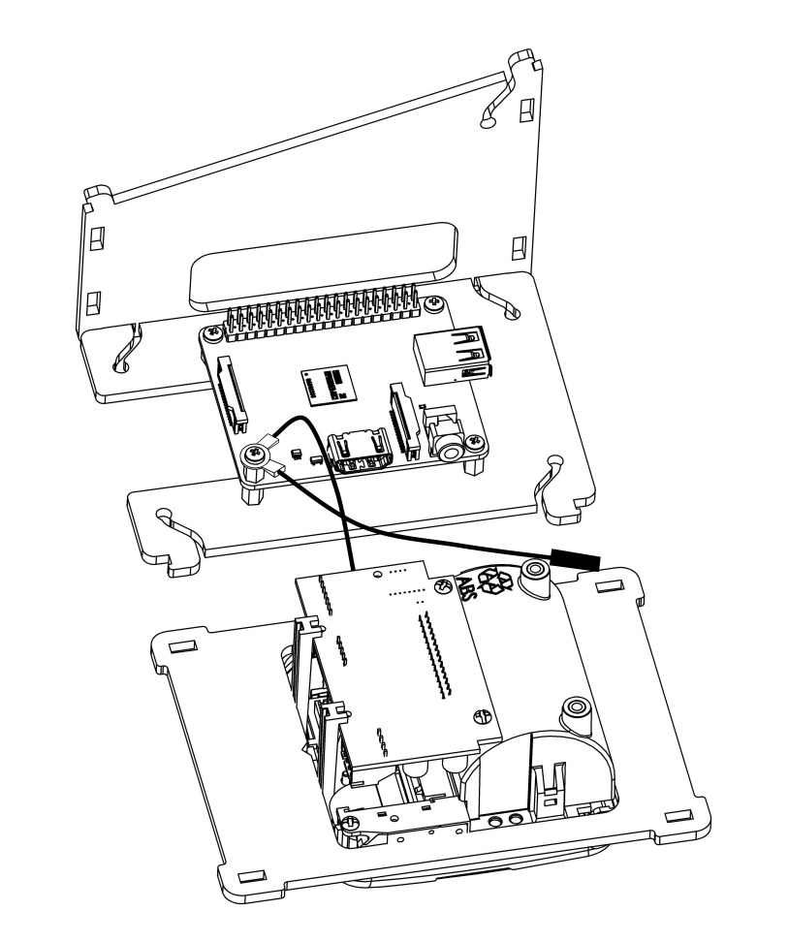

*Figure 6*

1. Fit the free end of the grounding wire to the **back right, inside** **pin** on the GPIO header, ensuring it is properly located as shown in *Figure 7*.

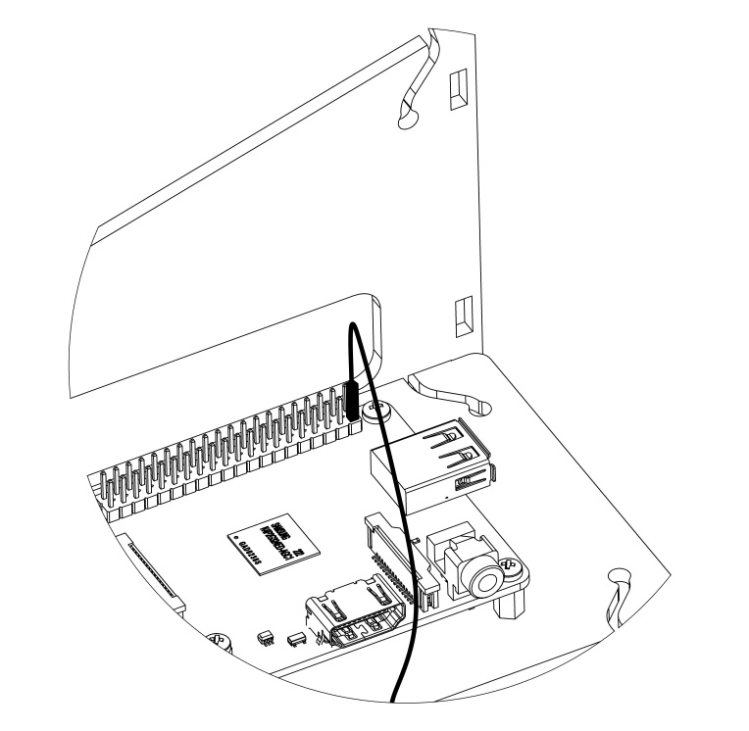

Figure 7

1. **Lay the unit on its side** and offer-up the back plastics to the rear of the assembly as shown in *Figure 8.* **Note the orientation of the large and small notch.**Locatethe Mini-B USB Data lead cable into the small left hand notch on the back plastics. The Mini USB connector should have sufficient slack for the connector to reach the front-right of the unit.

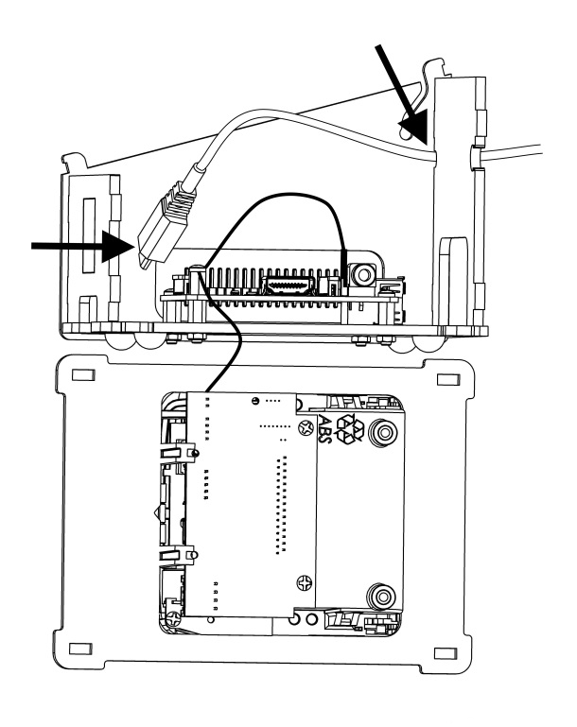

*Figure 8*

1. Ensuring that the USB lead remains in place, align the tabs of the back plastics in the slots on the side plastics.
2. Align the tabs of the front plastics in the slots on the side plastics.
3. Slide the knurled strain relief of the PSA Cable from the back of the unit into the right hand toothed slot in the back plastics, as shown in *Figure 9*. Press the PSA Cable forward until it is firmly trapped.

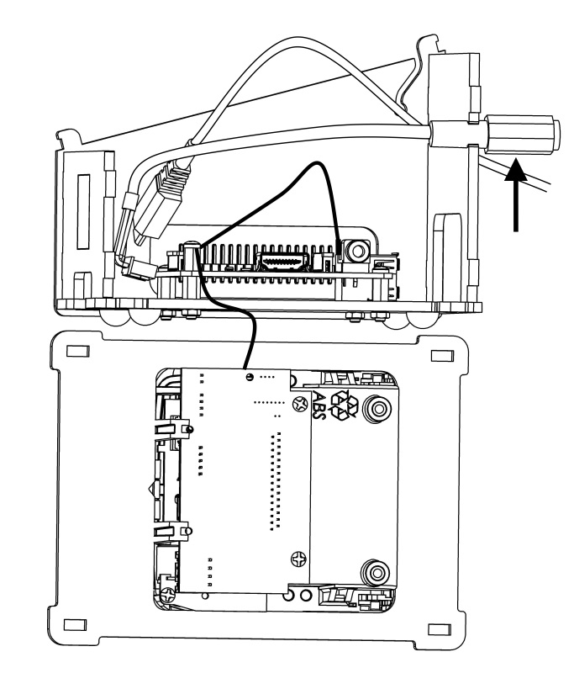

*Figure 9*

1. Move the printer and top plastics to the other side of the assembly. This will prevent the earth strap getting trapped during the next step.
2. Offer-up the right-hand side plastics to the assembly. Ensuring that the PSA Cable remains in place, locate the side plastics on the back tabs. Register the side plastics on the back base snap hook first, and bring the side plastics onto the front tabs, finally clipping the side in place on the front base snap hooks as shown in *Figure 10.*

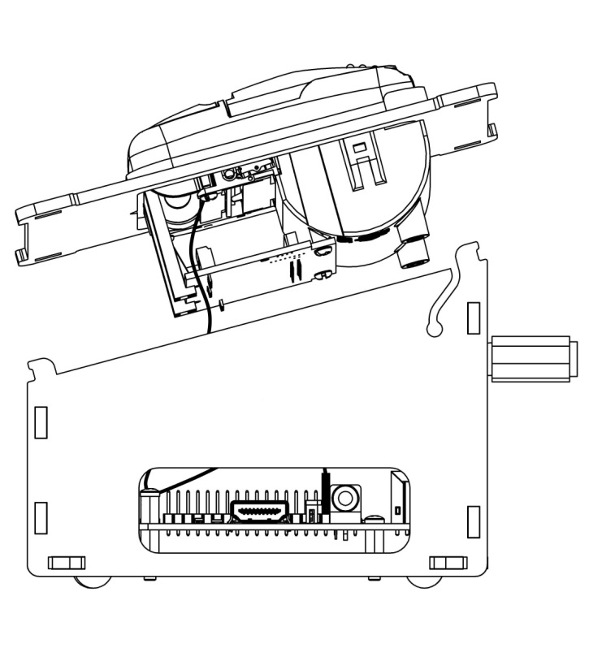

*Figure 10*

1. Pinching the left and right sides at the front in order to keep the unit together, lift the body and top plastics and place the unit on its rubber feet. Hook the top plastics over the front lugs as shown in *Figure 11*. Do not worry about the unconnected cables at this time!
2. Checking that the cables have not become dislodged from their respective notches, lower the lid down to engage with the rear snap hooks before pressing the top plastics firmly into place, as shown in *Figure 11*.

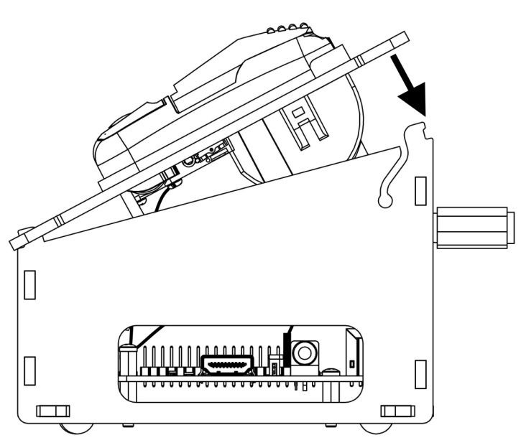

*Figure 11*

1. Lift the printer out of the top plastics and attach the Power Supply Adaptor and USB cable to the printer. The cables are intended to cross-over one-another under the body of the printer in order to take-up slack.
2. Adjust the position and length of the cables under the body of the printer until the printer sits flush with the top plastics.
3. Connect the free end of the Mini USB lead to the USB socket on the rear of the Raspberry Pi.
4. Taking care not to leave fingerprints in the adhesive, affix the label to the front of the unit, aligning it to the etched area.
5. Your Pipsta is now fully assembled.

# Next Steps

Now you have completed the mechanical build, see:

* ***PIPSTA004 – Pipsta First-Time Setup***

This tutorial will guide you step-by-step through the installation of the operating system through to installing Pipsta demonstration software and printing your very first message.

◼**End of Document**◼